select data, pesel_pacjenta from rejestracje
where kod_punktu_szczepien = 'P1' AND (plan_termin_1_dawki - data) <5
order by data asc, pesel_pacjenta;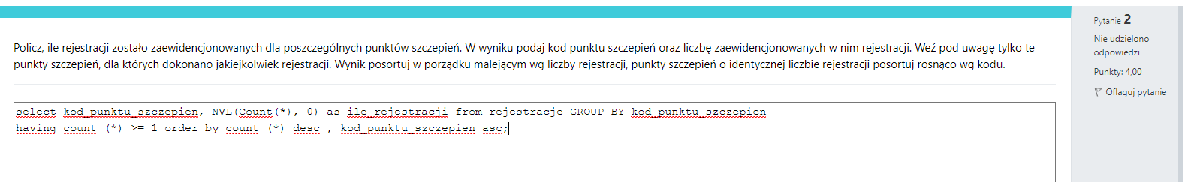
select kod_punktu_szczepien, NVL(count(*), 0) as ile_rejestracji from rejestracje GROUP BY kod_punktu_szczepien
having count(*) >= 1 order by count(*) desc, kod_punktu_szczepien asc;

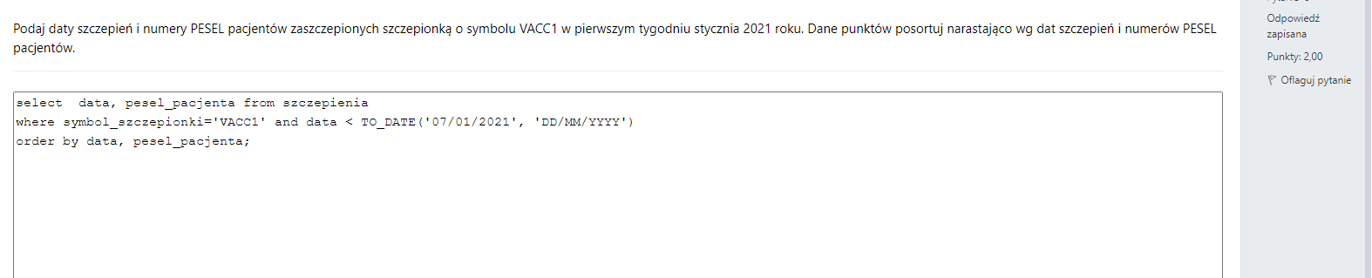
SELECT szczepienia.data, szczepienia.pesel_pacjenta FROM szczepienia WHERE szczepienia.data BETWEEN DATE '2021-01-01' AND DATE '2021-01-07' AND szczepienia.symbol_szczepionki = 'VACC1' ORDER BY szczepienia.data, szczepienia.pesel_pacjenta
SELECT data, pesel_pacjenta FROM szczepienia
WHERE data BETWEEN DATE '2021-01-01' AND DATE '2021-01-07' AND symbol_szczepionki = 'VACC1'
ORDER BY data, pesel_pacjenta;

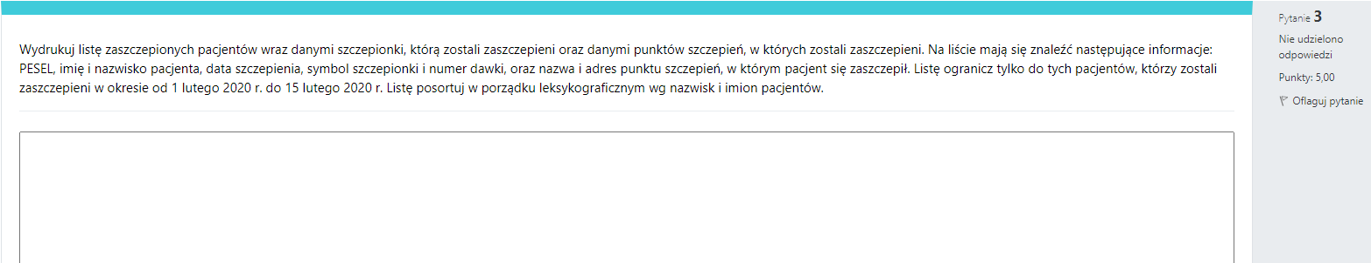

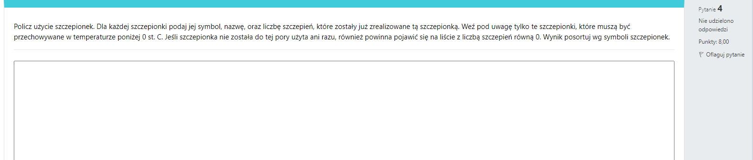

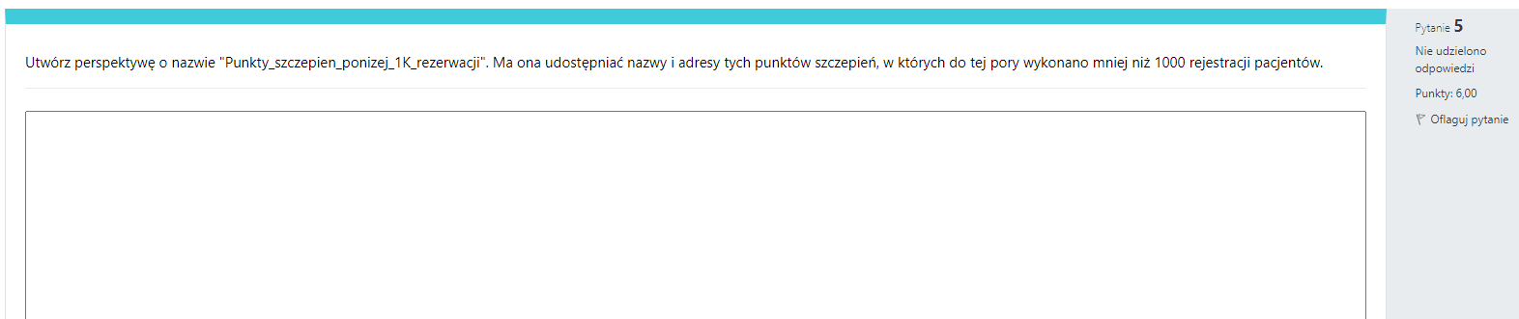

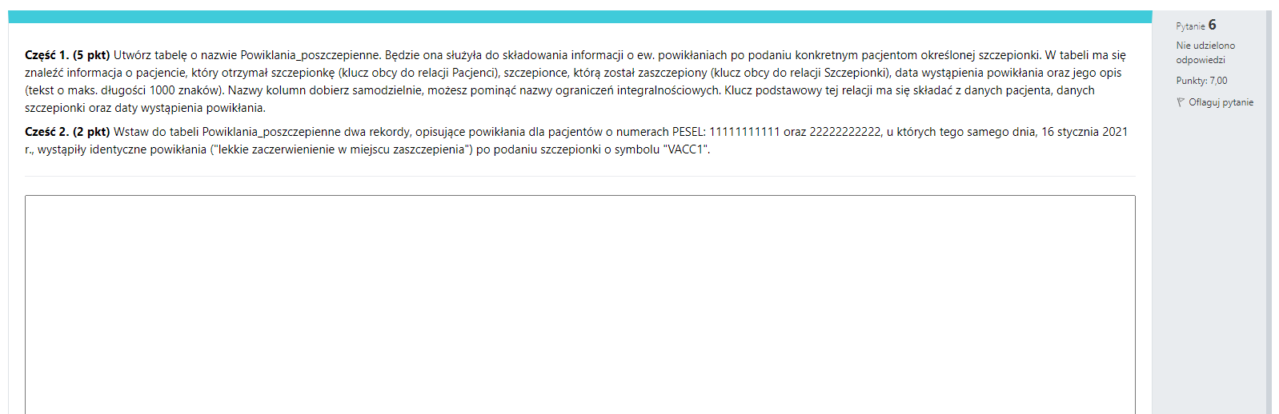

Zestaw 2

Mieszane
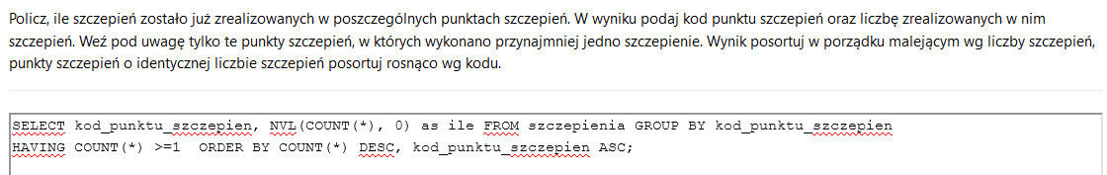
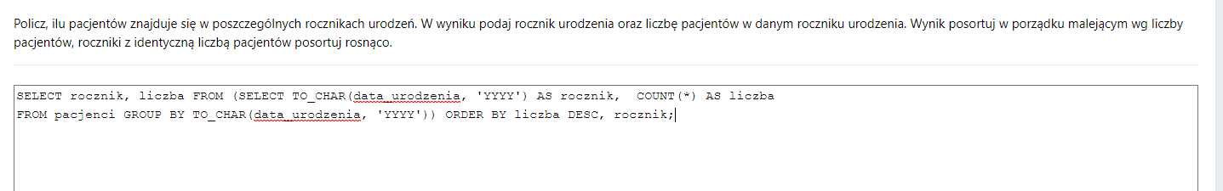
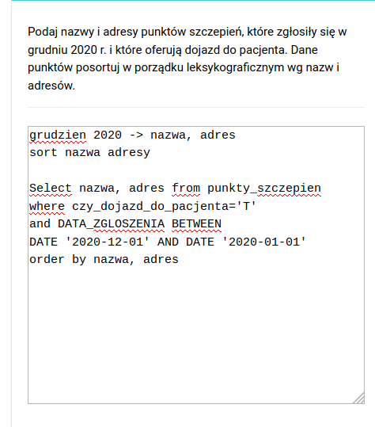
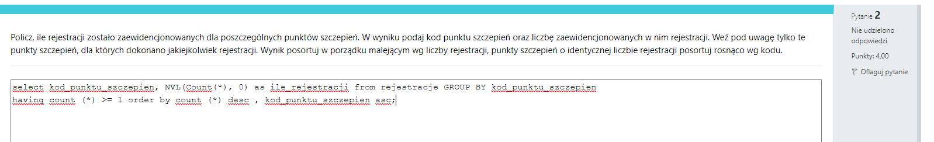
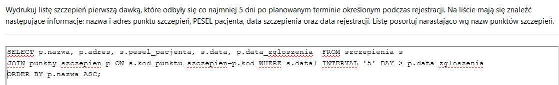
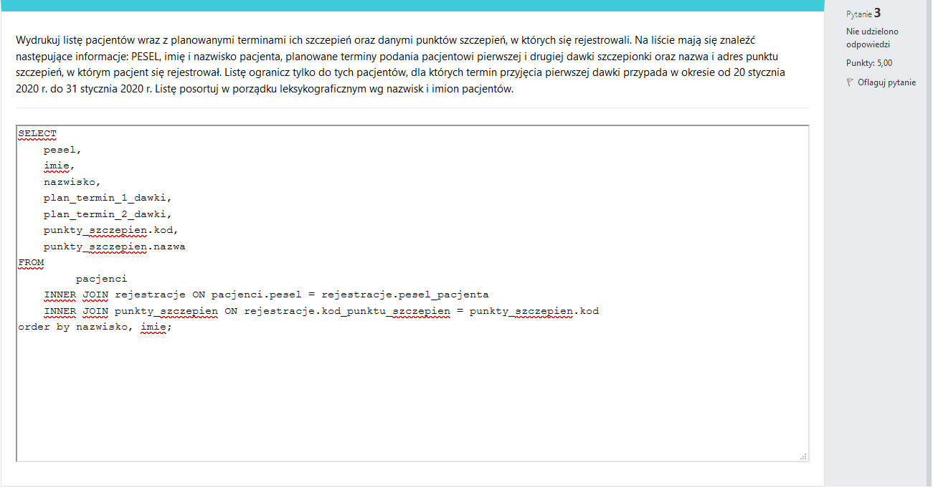
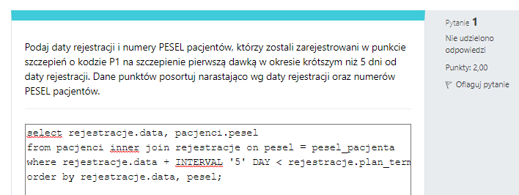
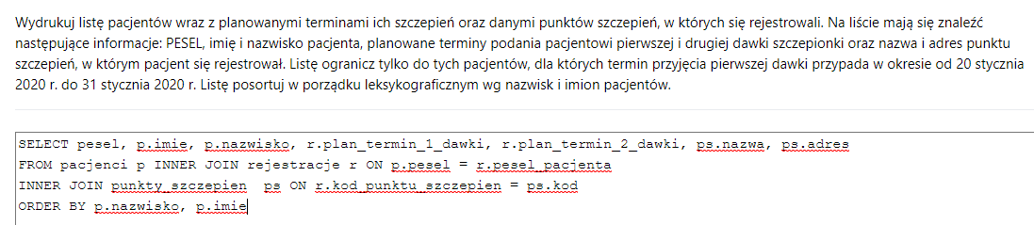

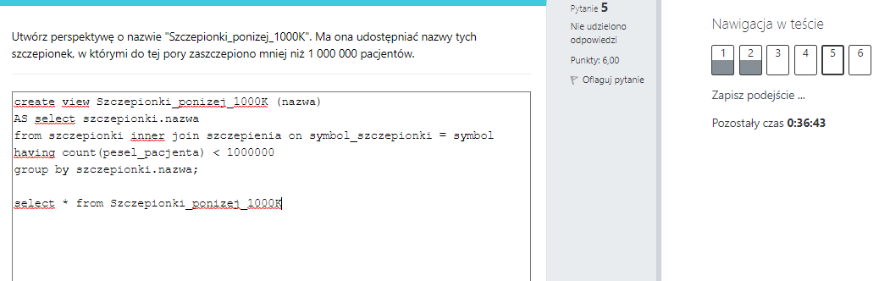
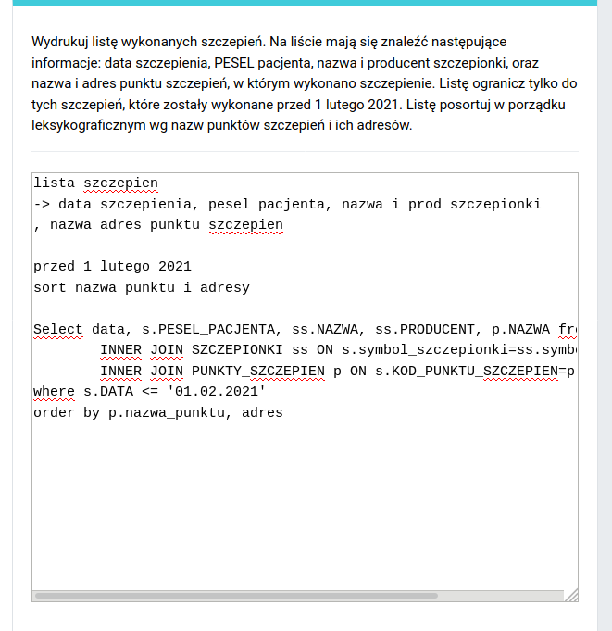
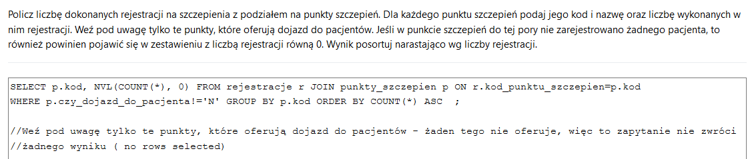

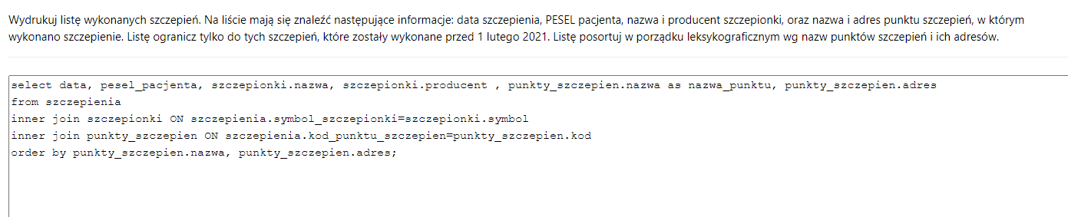
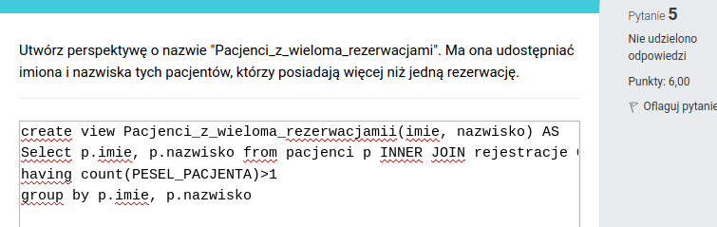
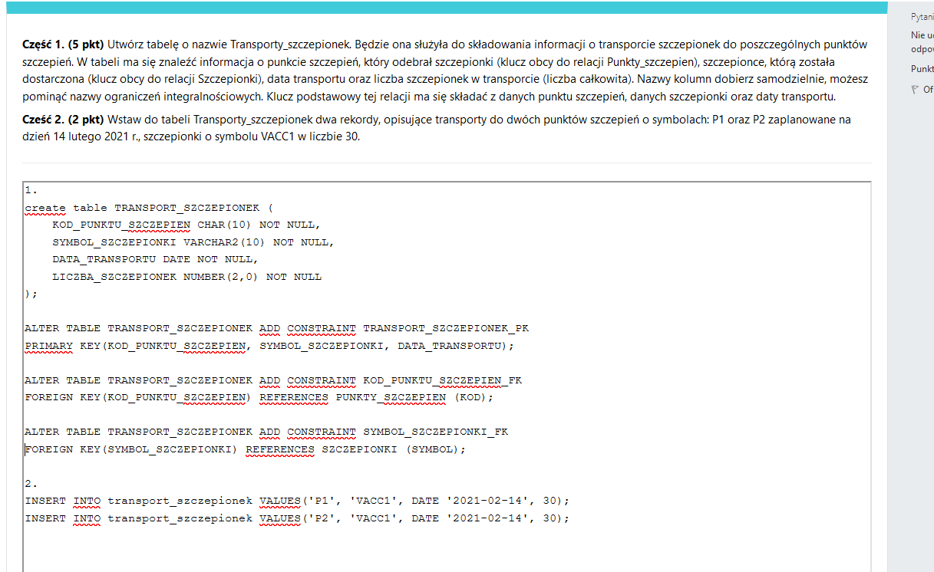
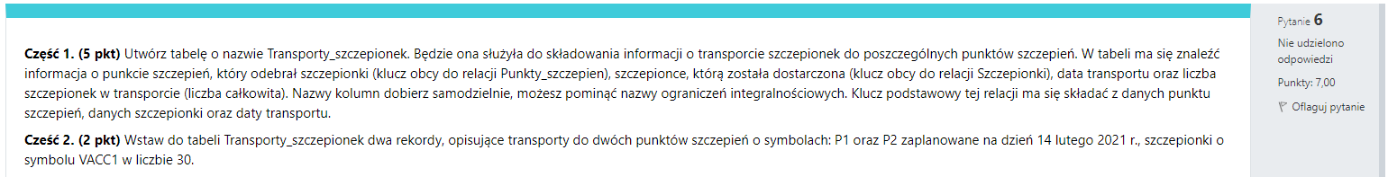

Zrobione Damiana:
